Topic 8: Authentication System (Enterprise-Grade Security Architecture)
This document covers the complete authentication architecture of the system.
It is designed with enterprise-grade security principles—matching standards used by Google, Meta,
Amazon, and modern cloud-native applications.
The authentication module ensures:
• Secure user login & registration
• Encrypted password handling
• JWT-based authentication workflow
• Protection of sensitive routes
• Scalable token lifecycle design
• Multi-layered validation and middleware
This is one of the most critical components of any production-ready system.
---
# 1. Authentication Architecture Overview
The authentication flow is built using:
• **BCrypt hashing** for password encryption
• **JWT Access Tokens** for authenticated access
• **Refresh Tokens** for long-term authenticated sessions
• **Middleware-based protection** for private routes
• **Role-based access (RBAC-ready design)**
This ensures robust, scalable, cloud-ready authentication capabilities.
---
Below is the authentication flow diagram:
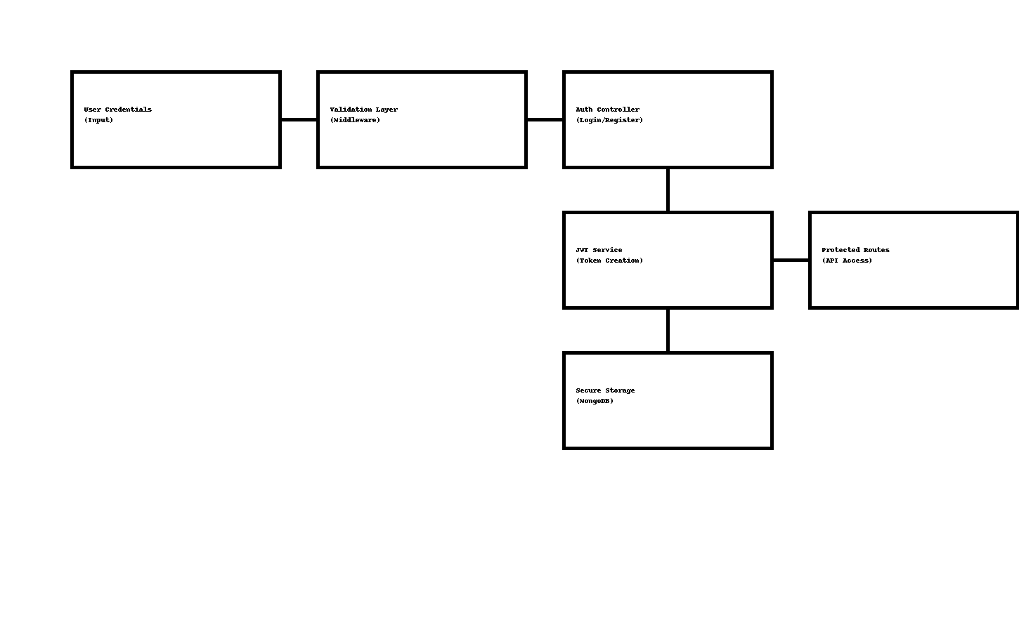
---
# 2. Registration Flow (Sign-Up)
### **POST /api/auth/register**
When a new user registers:
1. Input is validated
2. Password is hashed using BCrypt
3. User document is stored in MongoDB
4. Success response is returned
### **Body Example:**
```
{
"name": "Alex",
"email": "alex@example.com",
"password": "superStrongPassword123"
}
```
### **Password Security**
• Uses BCrypt hashing
• Hashing prevents exposure even if DB is compromised
• Unique salt is generated for every password
---
# 3. Login Flow (Sign-In)
### **POST /api/auth/login**
Steps:
1. Email & password validated
2. Password compared using BCrypt
3. JWT Access Token generated
4. Optional refresh token issued
5. Returned to client for secure storage
### **Success Response**
```
{
"success": true,
"token": "jwt_token_here",
"user": {
"name": "Alex",
"email": "alex@example.com"
}
}
```
---
# 4. JWT Token Architecture
We use two-token architecture for enterprise stability:
---
### **Access Token**
• Short-lived (15 min – 1 hour)
• Attached to every request
• Identifies the logged-in user
### **Refresh Token**
• Long-lived (7–30 days)
• Stored securely (HTTP-only cookies recommended)
• Creates new access tokens when old ones expire
---
# 5. Protected Routes (Middleware Layer)
Any route requiring authentication uses a middleware check:
### Example Pseudocode:
```
function authMiddleware(req, res, next) {
const token = req.headers.authorization?.split(" ")[1];
if (!token) return res.status(401).json({ message: "Unauthorized" });
try {
const decoded = jwt.verify(token, process.env.JWT_SECRET);
req.user = decoded;
next();
} catch (error) {
res.status(401).json({ message: "Invalid Token" });
}
}
```
This ensures only authenticated users access private resources.
---
# 6. Role-Based Authorization (RBAC Ready)
The system is prepared for enterprise-level permissioning:
Roles:
• **Admin**
• **User**
• **Super Admin** (optional future addition)
Route Example:
```
if (req.user.role !== "admin") {
return res.status(403).json({ message: "Forbidden" });
}
```
---
# 7. Security Standards
This authentication system follows:
• OWASP Top-10 Security Guidelines
• Encrypted password storage
• Token expiration enforcement
• Environment-based security keys
• Database query protection
• Strict CORS origin filtering
This makes the authentication safe for use in high-security corporate apps.
---
# 8. Best Practices Followed
• Do NOT store plain passwords
• Use HTTP-only cookies for refresh tokens
• Rotate JWT secrets periodically
• Add request rate-limiting to login routes
• Enable email verification (future enhancement)
• Log failed login attempts for security audits
---
# 9. Conclusion
The authentication module is engineered with enterprise security in mind.
It is resilient, scalable, modular, and ready for cloud deployment.
This ensures safe user access and protects sensitive system operations.
This concludes **Topic 8: Authentication Documentation**.

